Making a replica working plastic part, using silicone rubber and fastcast polyurethane resin.

Picture of the broken plastic part that we need to replicate. | 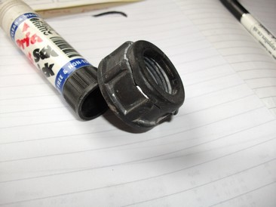
Showing the broken part and a good part from which we will take a mould. | 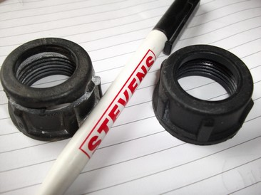
The good nut is inserted into a plastic cup with the upper surface to the bottom, the pictures opposite show the nut placed in the centre of the cup. | 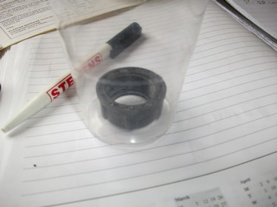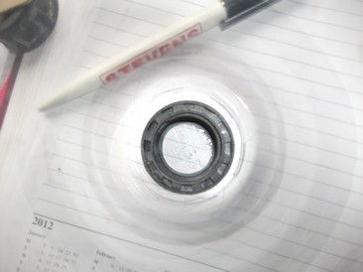
Approx 70g of silicone rubber is weighed into a separate mixing cup the hardener is added and the mix stirred thoroughly, the rubber was then de-aired in a vacuum chamber (some rubbers can eliminate the need for de-airing). | 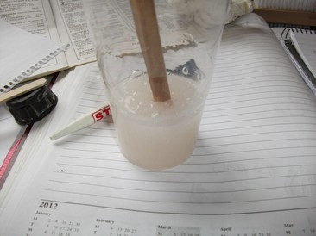
The rubber is then slowly poured into the edge of the cup to very slowly flood fill the part, ensure the part remains in the centre of the cup, move with a mix stick if required, the rubber is then left to fully cure. | 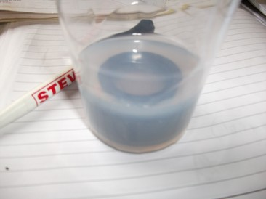
The rubber mould is then removed from the cup, carefully cut the rubber around the lip of the nut using a sharp blade; the nut can then be eased out of the mould. | 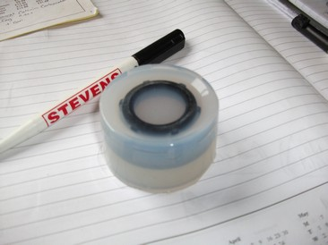

The part is taken out of the mould, the mould is now ready for use. | 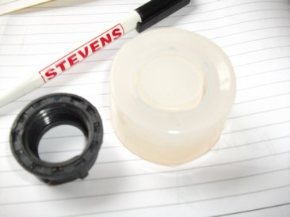
Pour and mix the two resin components A + B | 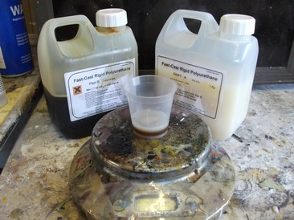
Slowly pour the resin into the mould, the slower the pour the less chance of trapping air bubbles resulting in a fault-free casting, leave the resin to fully cure before removal from the mould. | 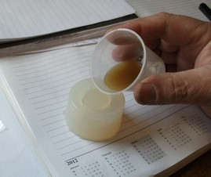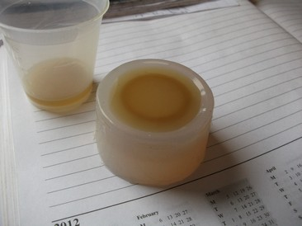
The cured casting can then be carefully removed from the mould, gentle flexing of the rubber mould ensures no damage is caused to the mould during removal. | 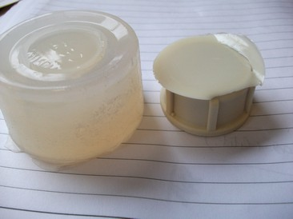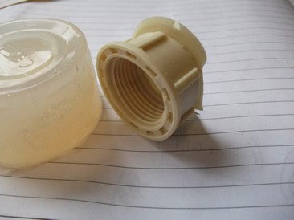
The casting can now be de-burred and the edges sanded, as you can see the results are quite impressive. | 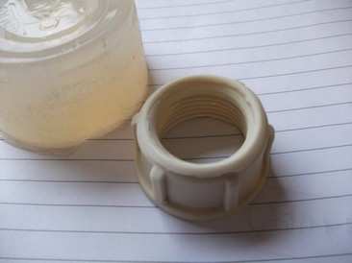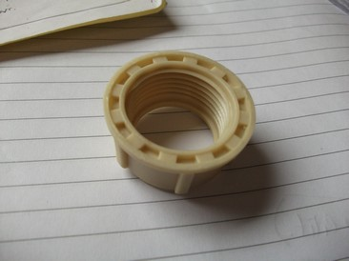
The casting is now screwed onto the sprayer head. | 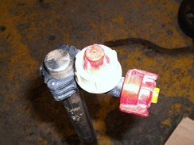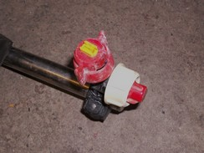
The materials used to produce this casting were:
150ml mix cups, 50ml measure cups, mix sticks.
75g of RTV silicone rubber.
10g of Fastcast PU casting resin (per casting).
The part has been fitted and successfully doing its job.

